Integration Analysis on boomi MarketPlace

Integration: Connect Workday to Salesforce

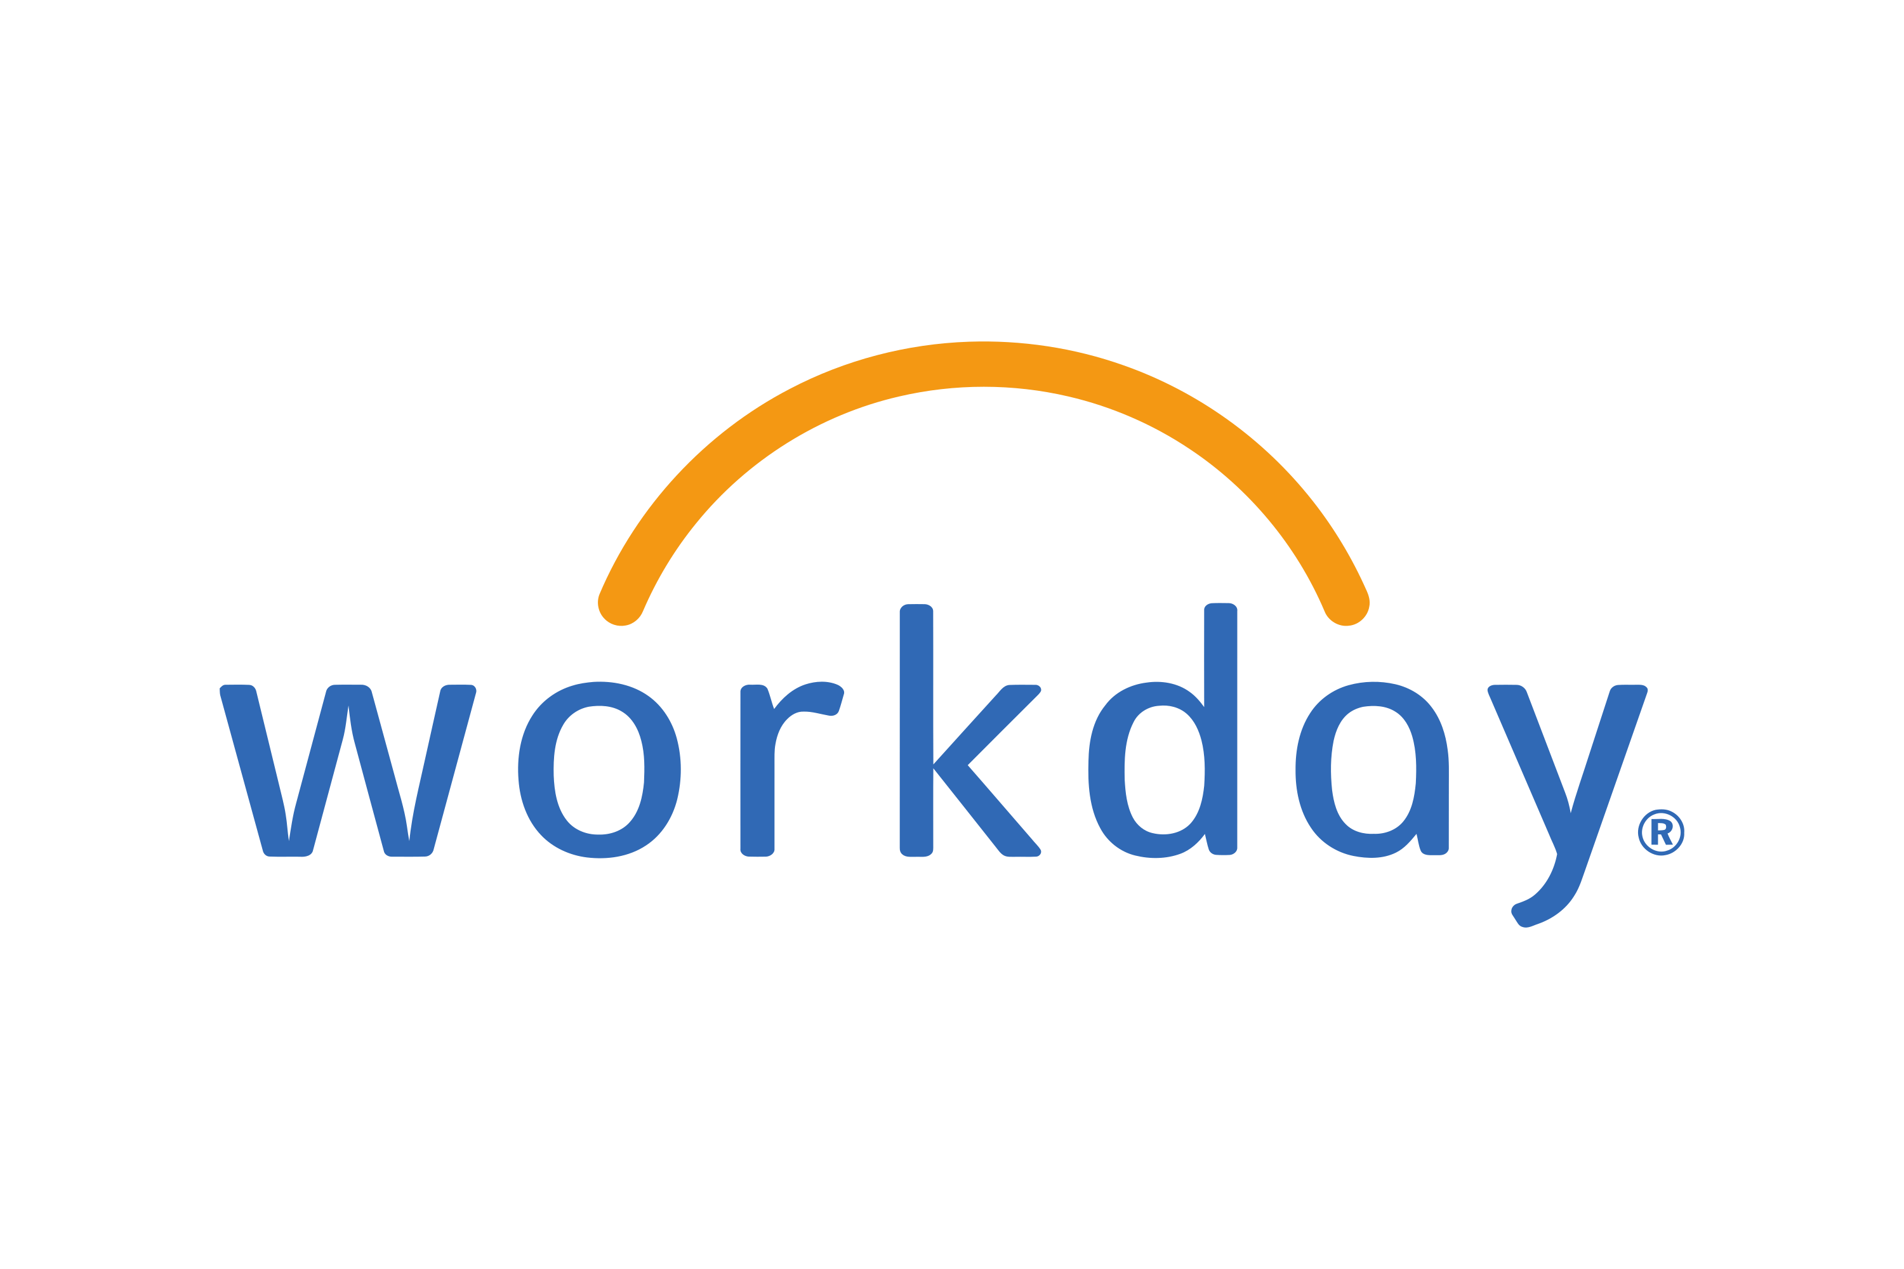

Interface Name | Sender | Receiver
Send Flat Files From an FTP Server to Salesforce to Create Contacts | Salesforce | Workday

1.ITR document extract
This integration orchestrates bi-directional data synchronization between Salesforce CRM and Workday HCM/Financial Management systems. The integration creates customers, projects, and contracts in Workday based on closed/won opportunities in Salesforce, then updates the corresponding Salesforce records with the generated Workday IDs.

Business Purpose: Automate the creation of customer master data, project structures, and contract records in Workday when sales opportunities are successfully closed in Salesforce, ensuring data consistency across both systems.
Authentication Mechanisms: - Salesforce: OAuth 2.0 or Session-based authentication - Workday: WS-Security with username/password or certificate-based authentication

General Response Format: XML for Workday operations, JSON for Salesforce operations

Rate Limiting: Subject to Salesforce API limits (typically 100,000 API calls per 24 hours) and Workday API limits (varies by tenant)

1.2 business flow in Boomi

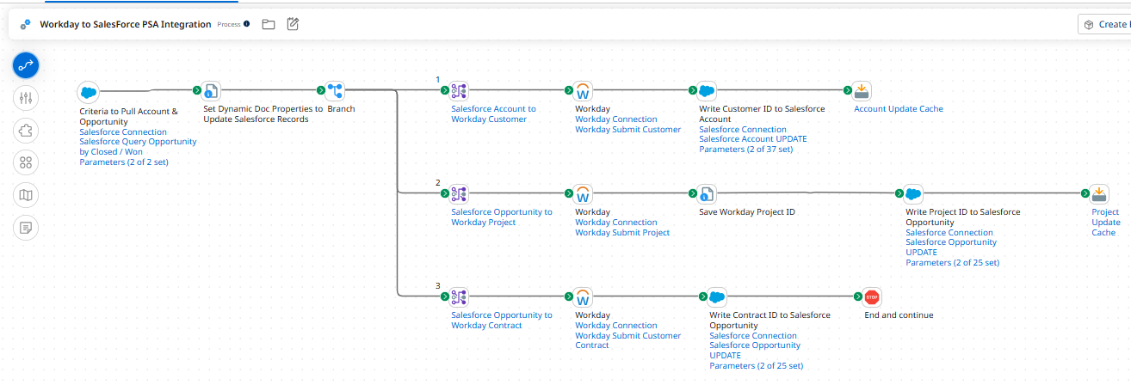

This process shows a representative end-to-end integration of Salesforce Accounts and Opportunities (w/lines) to Workday Customer, Contracts, and Projects. Accounts and Opportunities are extracted from Salesforce based on Opportunity Close Date and sent to Workday using the Workday Web Services to create or update Customer. Contracts and Projects are inserted into Workday in draft mode. The process and map include techniques to then write the Workday IDs to Salesforce and Salesforce IDs to Workday. The SalesForce query operation is configurable and set to query Opportunities that have a 90% closure probability since the last successful execution of the process.

- Start step for Query Salesforce call 2. Set Properties 3. Three sequential Branches with individual mappings, Workday Connectors & Salesforce Connectors 4. First two branches are Ending with Cache step and Last Branch with Stop.

SAP BTP IS ITR-Design doc flow

Analysis
- Query starts from Accounts and Opportunities are extracted from Salesforce based on Opportunity Close Date >> Content Modifier with properties after Salesforce adapter.

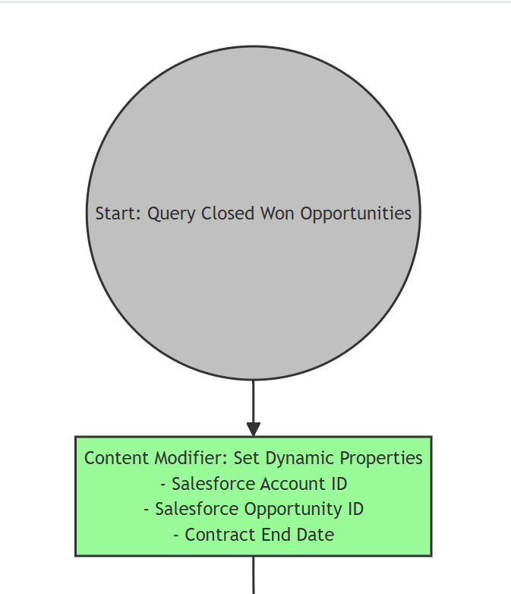

- The sequence is Create a new customer, New Project, New contract. So, instead of parallel multicast the Sequential Multicast step should be here

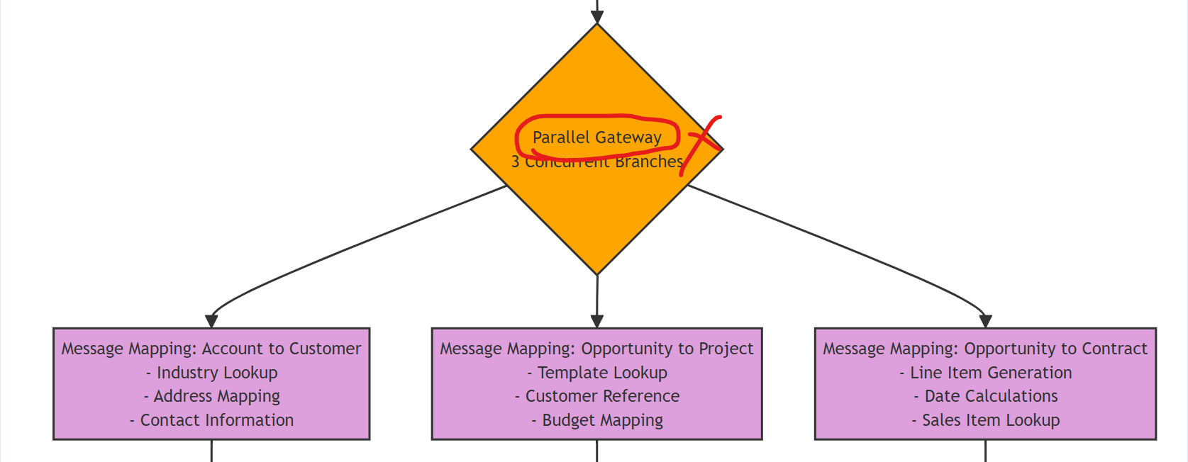

Brach: 1

- Message Mapping for Account to Customer & Salesforce Adapter represented Correct. But the Integration Suite offers Workday Adapter with basic Authentication. here mentioned as HTTPS adapter.

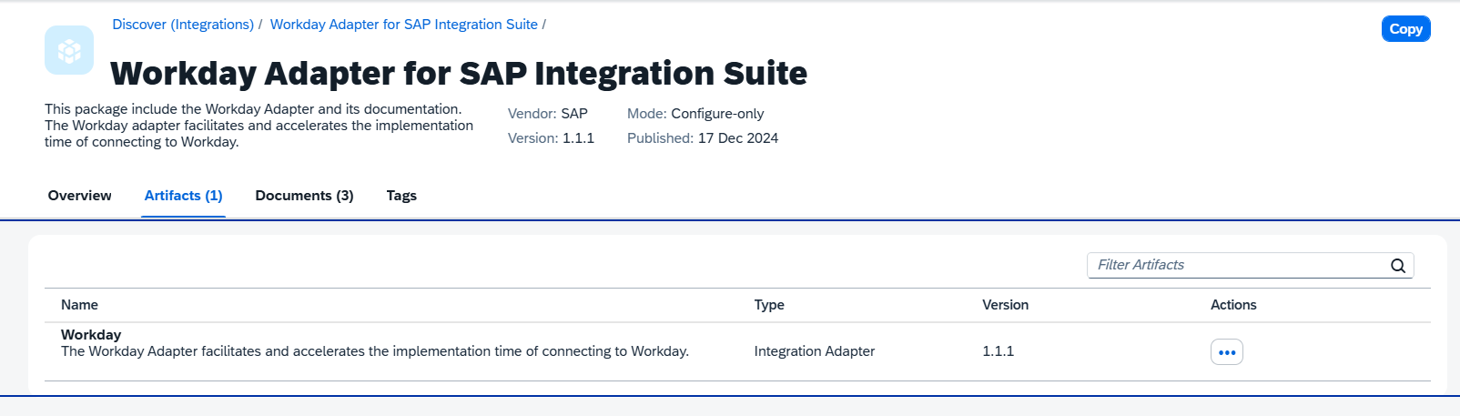

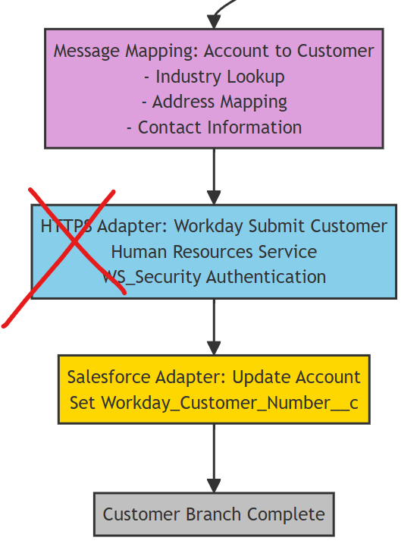

Branch: 2

- Message Mapping for Opportunity to Project & Salesforce Adapter represented Correct. the Integration Suite offers Workday Adapter. here mentioned as HTTPS adapter. Content modifier to Store Project ID.

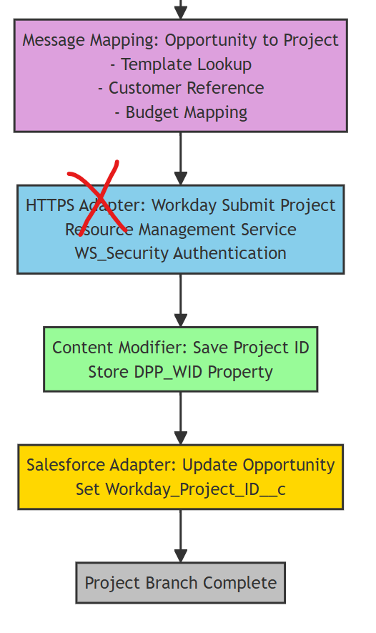

Branch: 3

- Message Mapping for Opportunity to Contract & Salesforce Adapter represented Correct. the Integration Suite offers Workday Adapter. here mentioned as HTTPS adapter.

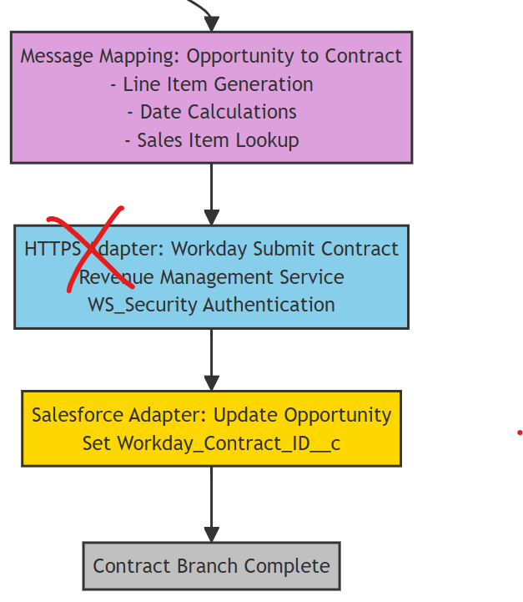

All Branches End.

- Sequential Multicast should always close with end Message, instead of branch Complete, it should mention as End Message for Closure.

